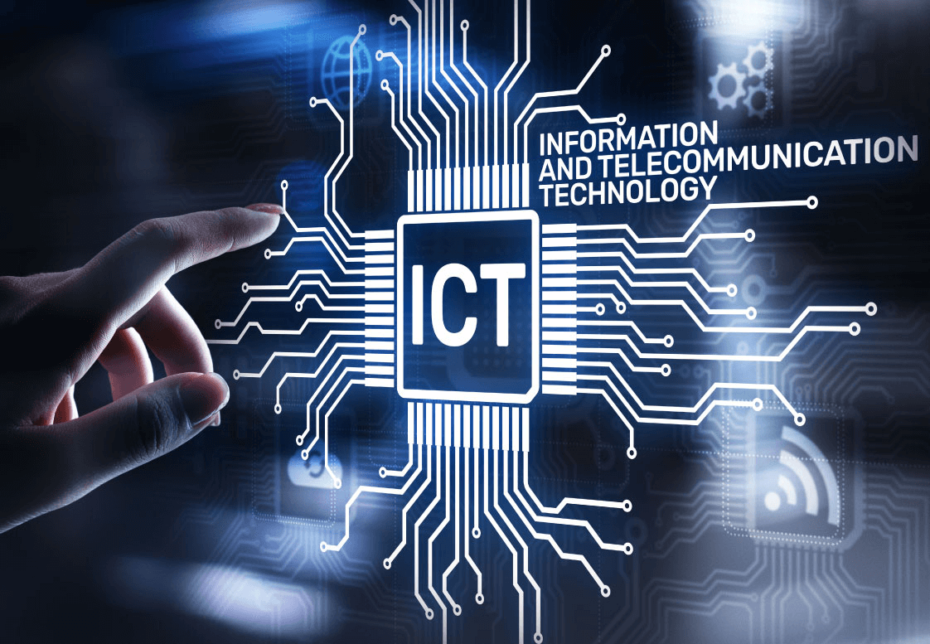

**The Evolution, Impact, and Future Trends of Information and Communication Technologies (ICT) and Related Technologies**

Made by : **Groupe 3**

Members :

* AMIRI Mourad
* ELBAH Fadi
* BELDJOUDI Imene
* DJERALFIA Mohamed
* BERKANI Ahmed

1. **Introduction:**

Information and Communication Technologies (ICT) have undergone a remarkable evolution, shaping the modern world and influencing the way individuals, businesses, and societies interact. As we delve into this report, we aim to provide a comprehensive overview of the historical development and contemporary impact of ICT, with a specific focus on key technologies such as Google services, Microsoft tools, and version control systems like Git and GitHub, we will also delve into the role of languages like HTML, CSS, and LaTeX in shaping the digital ecosystem.

Since that, let’s begin by understanding what ICT (Information and Communication Technologies) means:



# Information and Communication Technologies (ICT) :

# 2.1 Definition and Scope :

# The expansive realm of ICT encompasses a diverse array of technologies employed for the creation, storage, processing, and exchange of information. This includes hardware, software, networks, and applications that collectively form the backbone of our digital infrastructure. The evolution of ICT has not been a linear progression rather, it has been marked by paradigm shifts driven by advancements in computing power, connectivity, and the increasing complexity of societal needs.

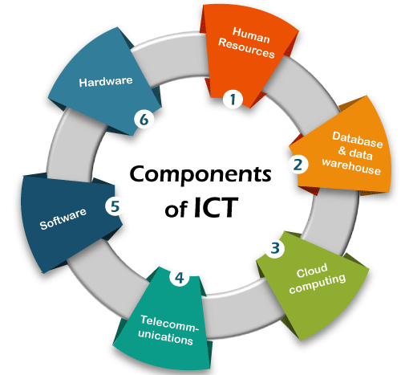

**2.2 Evolution of ICT :**

The evolutionary trajectory of ICT can be traced from the advent of computers and the inception of the internet. From the era of mainframes to the democratization of computing through personal computers, and from the early days of dial-up connections to the current era of high-speed broadband and mobile technologies, the landscape of ICT has seen unprecedented transformations. The emergence of cloud computing and the Internet of Things (IoT) further add layers of complexity to the ever-expanding ICT ecosystem.



**3. Google Services:**

|  |  |
| --- | --- |
| **3.1 Overview:** | Google, a global technology giant, has positioned itself as a leader in providing a comprehensive suite of services that have become integral to daily life. Google Search, Gmail, Google Drive, and Google Maps exemplify the diverse range of tools that have redefined how people access, share, and manage information |
| **3.2 Impact:** | The impact of Google services on communication, collaboration, and information retrieval cannot be overstated. Google Drive's cloud-based infrastructure facilitates seamless collaboration, allowing individuals and businesses to work on documents in real-time, transcending geographical boundaries. Gmail, with its intuitive interface and powerful features, has become one of the most widely used email platforms globally. Furthermore, Google's search engine has fundamentally altered how individuals access and consume information, shaping the digital landscape and influencing user behavior on a global scale. |

**Some of Google Services:**

**4. Microsoft Tools:**

|  |  |
| --- | --- |
| **4.1 Overview:** | Microsoft, another industry titan, offers a suite of tools and software applications that have become ubiquitous in both personal and professional realms. Microsoft Office, the Windows operating system, and Azure cloud services exemplify Microsoft's pervasive influence in the technology landscape. |
| **4.2 Impact:** | Microsoft tools have played a pivotal role in shaping productivity standards across diverse sectors. Applications such as Word, Excel, and PowerPoint are ingrained in business and educational workflows, providing robust solutions for document creation, data analysis, and presentation. The Windows operating system remains the dominant platform for personal computers, illustrating Microsoft's enduring impact on the desktop computing experience. Azure, Microsoft's cloud computing platform, has facilitated the migration to and management of cloud-based solutions for businesses of all sizes, underscoring the company's commitment to driving innovation in the digital age. |

**Some of Microsoft tools:**

**5. Git and GitHub:**

|  |  |
| --- | --- |
| **5.1 Overview:** | Git, a distributed version control system, and GitHub, a web-based platform for version control and collaboration, have emerged as indispensable tools in the realm of software development. Git allows multiple developers to collaborate seamlessly on a project, while GitHub provides a platform for hosting and managing code repositories. |
| **5.2 Impact:** | The transformative impact of Git and GitHub on software development workflows cannot be overstated. These tools enable collaborative coding, efficient version control, and streamlined issue resolution. Open-source projects, in particular, benefit immensely from the transparency and collaboration facilitated by these technologies. Developers can contribute to projects seamlessly, track changes, and resolve conflicts efficiently, fostering a global community of collaboration. |

**Git and GitHub logos:**

**6. HTML and CSS:**

|  |  |
| --- | --- |
| **6.1 HTML:** | HTML, the markup language that underpins the World Wide Web, has evolved from its early iterations to HTML5, introducing new features and capabilities. It provides the structural foundation for web content, defining elements such as headings, paragraphs, links, and multimedia. |
| **6.2 CSS:** | Complementing HTML, Cascading Style Sheets (CSS) dictate the visual presentation of web content. From colors and fonts to layout and responsiveness, CSS empowers developers to craft aesthetically pleasing and user-friendly websites. The evolution of CSS has paralleled the demand for richer and more dynamic web experiences. |

**Html and Css logos:**

**7. LaTeX:**

|  |  |
| --- | --- |
| **7.1 Overview:** | LaTeX, a typesetting system, has found its niche in the creation of scientific and technical documents. Renowned for its robust handling of complex mathematical equations and structures, LaTeX has become the standard for producing scholarly papers, theses, and publications. |
| **7.2 Impact:** | Beyond its primary use in academia, LaTeX's influence extends to various technical and scientific disciplines. Its emphasis on high-quality typesetting ensures the clear and professional presentation of intricate information. LaTeX documents, often utilized in collaborative research endeavors, contribute to the dissemination of knowledge in a standardized and visually appealing format. |

**LaTeX logo:**

**8. Challenges and Future Trends:**

**8.1 Challenges:**

Despite the myriad benefits ICT brings, it is not without challenges. Cybersecurity threats, digital divides, and ethical considerations pose ongoing challenges. The increasing interconnectivity of devices and systems amplifies the potential impact of cybersecurity threats, necessitating constant vigilance and innovation in security measures. Digital divides, both within and between nations, underscore the importance of inclusive and equitable access to technology. Ethical considerations, ranging from data privacy to the responsible use of emerging technologies, require thoughtful and proactive approaches to ensure the responsible development and deployment of ICT.



**8.2 Future Trends:**

Emerging technologies, including artificial intelligence, 5G, and quantum computing, are poised to redefine the future of ICT. Artificial intelligence, with its ability to analyze vast amounts of data and make informed decisions, holds the promise of transforming industries such as healthcare, finance, and manufacturing. The rollout of 5G networks is set to revolutionize connectivity, enabling faster and more reliable communication, and unlocking new possibilities for IoT applications. Quantum computing, still in its nascent stages, has the potential to solve complex problems at speeds unattainable by classical computers, opening new frontiers in scientific research, cryptography, and optimization.



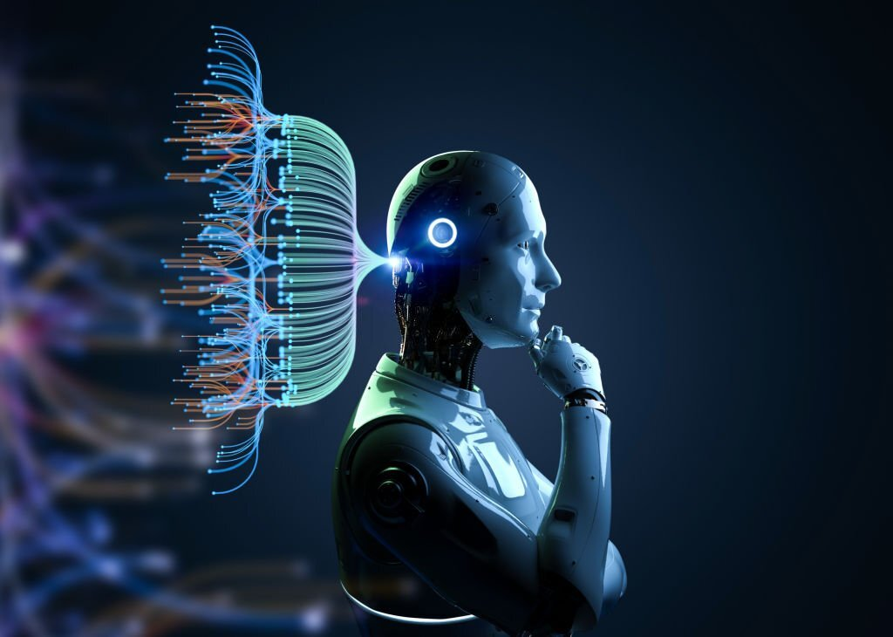

**9. Conclusion:**

In conclusion, the evolution, impact, and future trends of Information and Communication Technologies paint a dynamic picture of a constantly evolving digital landscape. From the foundational technologies offered by Google and Microsoft to the collaborative tools like Git and GitHub and the languages shaping the web and scientific documentation (HTML, CSS, LaTeX), each component plays a crucial role in defining the digital era. As we navigate the challenges and embrace future trends, it is imperative to strike a balance between innovation, inclusivity, and ethical considerations. The journey of ICT is an ongoing exploration, and with strategic collaboration and responsible implementation, we can harness its full potential for the betterment of society.





